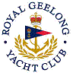 | Royal Geelong Yacht Club Inc.  Est 1859
Trophy Deed of Gift.

Trophy: | Les & Ivy King Trophy
Presented by: | Les & Ivy King
Date:
For: | Best Trier (Cadets)
Remarks / Revisions

